Mathematics: Units 3C and 3D
Formula sheet

Number and algebra

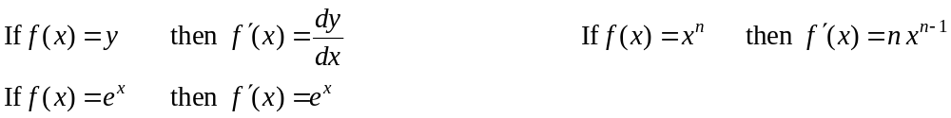

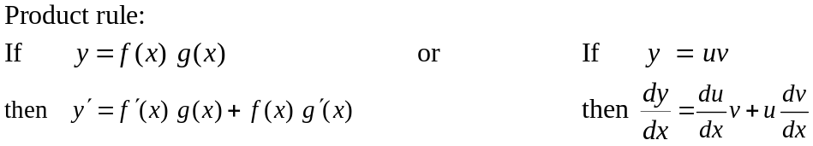

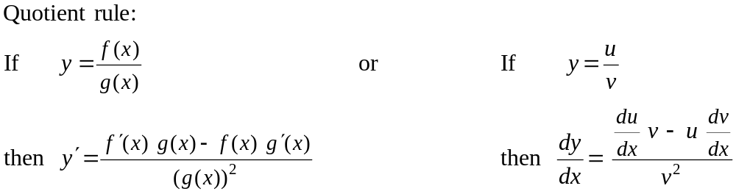

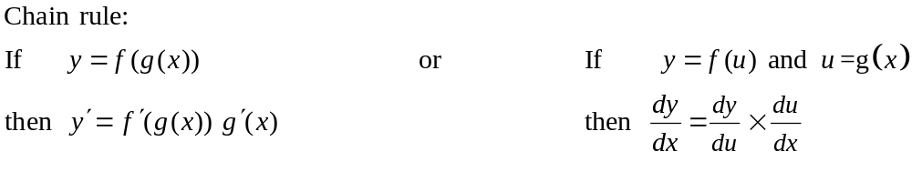
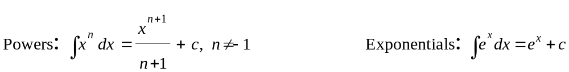

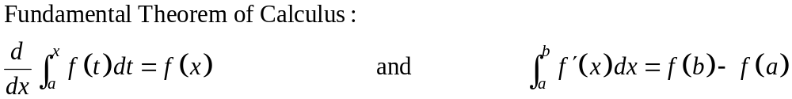

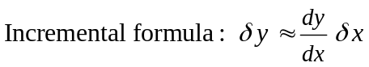

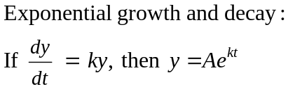

Space and measurement

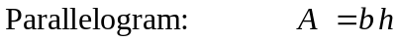
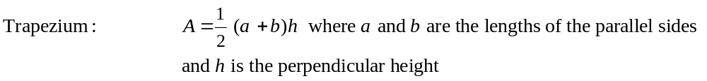
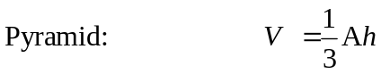
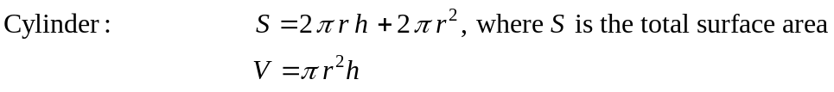
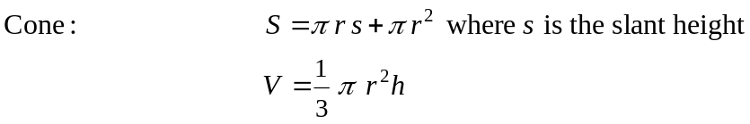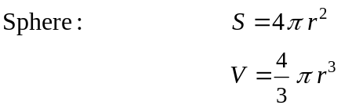

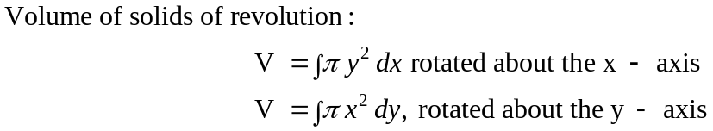

Chance and data

Probability laws:

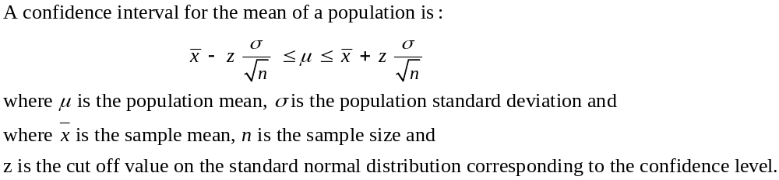

Note: Any additional formulas identified by the examination panel will be included in the body of the particular question.

